**Data Structure**

**&**

**Algorithm**

**Class 8**

**Lab 15**

|  |
| --- |
| **Lab Objectives:** Doubly Linked ListCircular Linked List |

# Data Structure - Doubly Linked List

## Doubly Linked List is a variation of Linked list in which navigation is possible in both ways, either forward and backward easily as compared to Single Linked List.

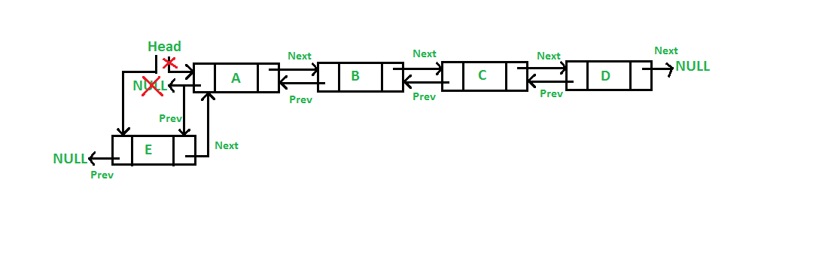

## following are the important terms to understand the concept of doubly linked list.

## ***Link***− Each link of a linked list can store a data called an element.

## ***Next***− Each link of a linked list contains a link to the next link called Next.

## ***Prev***− Each link of a linked list contains a link to the previous link called Prev.

## ***LinkedList***− A Linked List contains the connection link to the first link called First and to the last link called Last.

# Doubly Linked List Representation

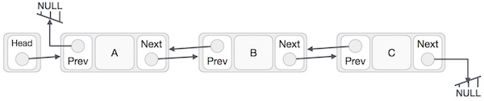

## As per the above illustration, following are the important points to be considered.

## Doubly Linked List contains a link element called first and last

## Each link carries a data field(s) and two link fields called next and prev.

## Each link is linked with its next link using its next link.

## Each link is linked with its previous link using its previous link.

## The last link carries a link as null to mark the end of the list.

# Basic Operations

## Following are the basic operations supported by a list.

## Insertion − Adds an element at the beginning of the list.

## Deletion − Deletes an element at the beginning of the list.

## Insert Last − Adds an element at the end of the list.

## Delete Last − Deletes an element from the end of the list.

## Insert After − Adds an element after an item of the list.

## Delete − Deletes an element from the list using the key.

## Display forward − Displays the complete list in a forward manner.

## Display backward − Displays the complete list in a backward manner.

# Data Structure - Circular Linked List

## Circular Linked List is a variation of Linked list in which the first element points to the last element and the last element points to the first element.

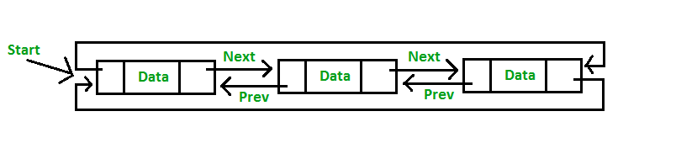

## Both Singly Linked List and Doubly Linked List can be made into a circular linked list.

# Singly Linked List as Circular

## In singly linked list, the next pointer of the last node points to the first node.

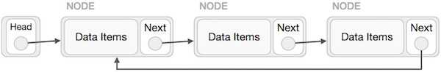

# Doubly Linked List as Circular

## In doubly linked list, the next pointer of the last node points to the first node and the previous pointer of the first node points to the last node making the circular in both directions.

## IMG_257As per the above illustration, following are the important points to be considered.

## The last link's next points to the first link of the list in both cases of singly as well as doubly linked list.

## The first link's previous points to the last of the list in case of doubly linked list.

# Basic Operations

## Following are the important operations supported by a circular list.

## insert − Inserts an element at the start of the list.

## delete − Deletes an element from the start of the list.

## display − Displays the list.